OPTICAL ILLUSIONS
These are sometimes referred to as visual illusions.
They refer to objects whose visual interpretation differs from reality.
- Muller-Lyer illusion
Consider the following figure:
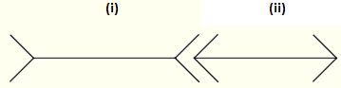
Which line is longer?
The left line (i) seems longer than line (ii).
However the two lines are of the same length.

- Ponzo illusion
Consider the following figure:
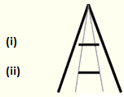
Which block is bigger?
The top block (i) seems bigger than block (ii) [due to the distance effect].
However the two blocks are of the same size.

- Ebbinghaus illusion (or Titchener circles)

Which orange circle is bigger?
The orange circle on the right seems bigger.
However, the two orange circles are of the same size.

- Ehrenstein illusion
Consider the following figure:
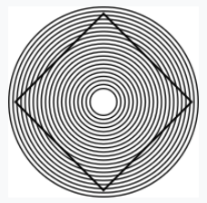
The sides of the square placed inside the pattern of concentric circles seem to take a curved shape. [However, the sides are straight lines of a square.]

- Proof-reading illusion
Consider the following text:
The quick brown
fox jumps over the
the lazy dog.

Most people reading this rapidly will read it without noticing that the word ‘the’ is repeated.

Question: Describe other optical illusions. For instance: Silhouette illusion, Fraser spiral illusion, Hering illusion, etc.

